AI ASSISTANT CODING
ASSIGNMENT-14
NAME: THRISHALA JAKKARAJU
HALLTICKET:2303A51514
BATCH:22

Task Description 1 – (Landing Page Design)
• Create a simple landing page for a product or service. Include a
header, hero section, and footer.
Requirements:
• Use HTML and CSS to structure the page.
• Use AI to suggest layout alignment and typography.
• Ensure the page is responsive across devices.
Prompt: Create a simple landing page for a product or service. Include a header, hero section, and footer
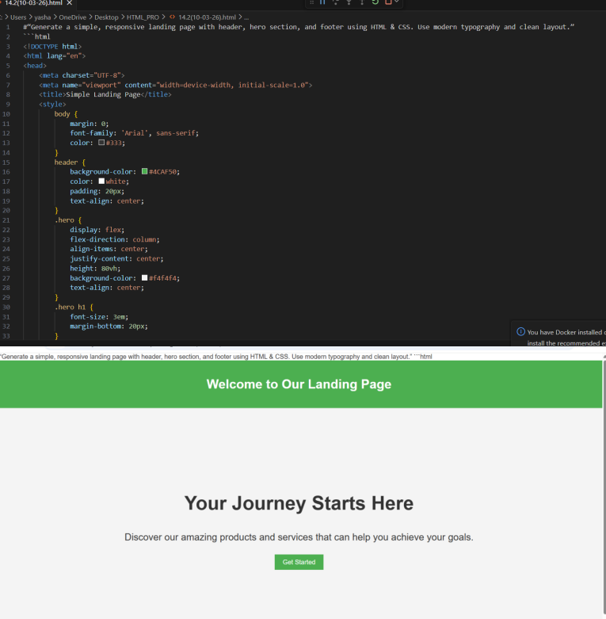

TASK Description 2 – (Theme Toggle Feature)
• Provide a button to switch between light and dark themes..
Requirements:
• Use JavaScript to toggle CSS classes.
• Use AI assistance to manage color contrast and accessibility.
• Ensure theme preference applies instantly on click.
Prompt: Add a JavaScript button that toggles between light and dark theme by switching CSS classes.
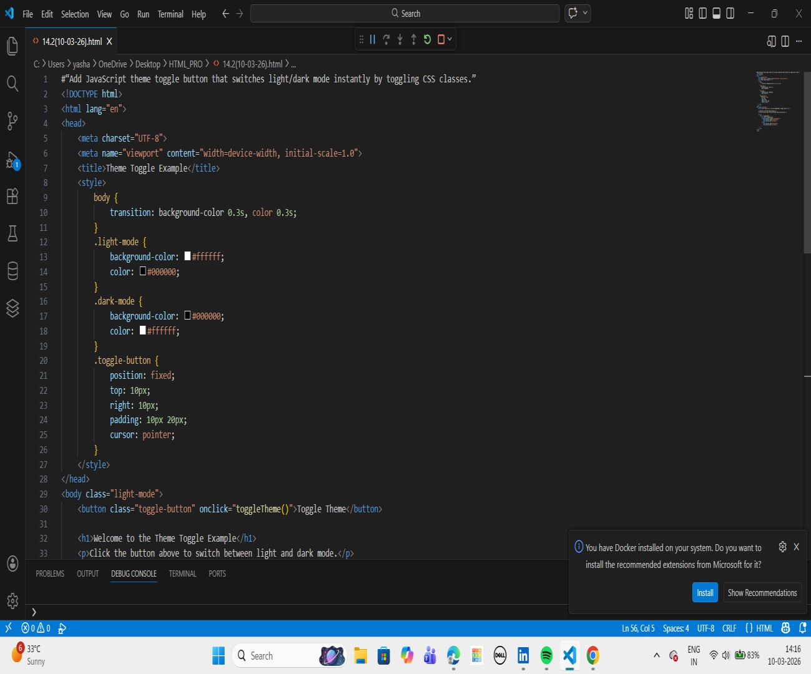
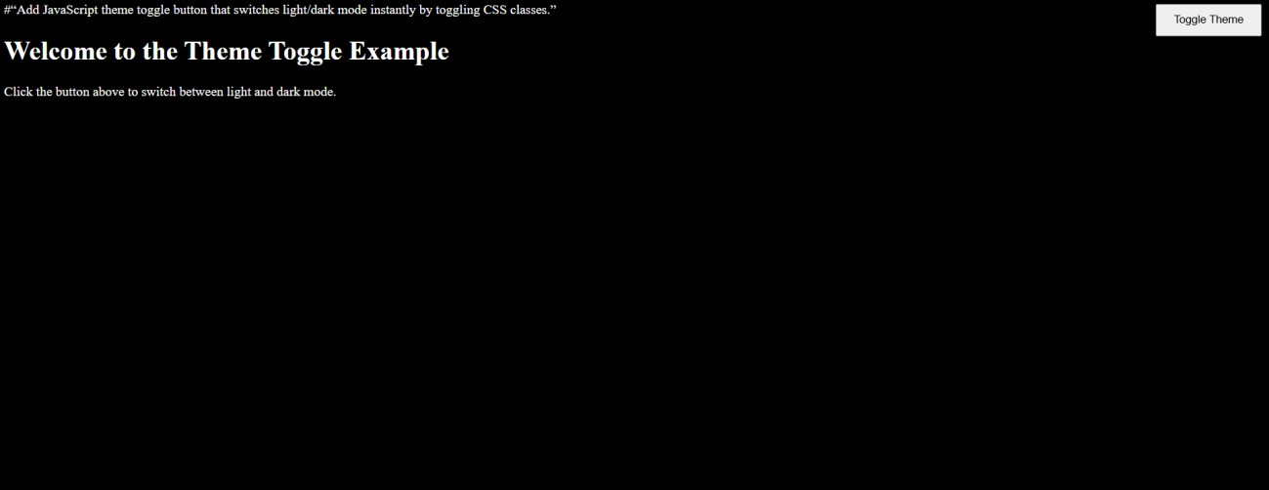

Task Description 3 – (User Feedback Form)
• Create a feedback form with fields: Username, Rating,
Comments.
Requirements:
• Use JavaScript to validate required fields.
• Display success or error messages dynamically.
• Use AI to improve form usability and layout.
Prompt: Create a feedback form with validation and dynamic success/error messages using JavaScript.
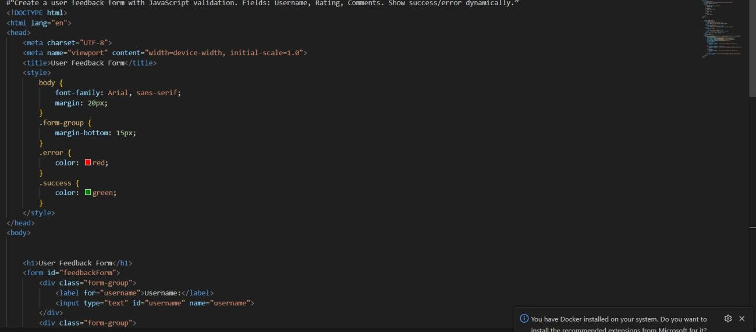

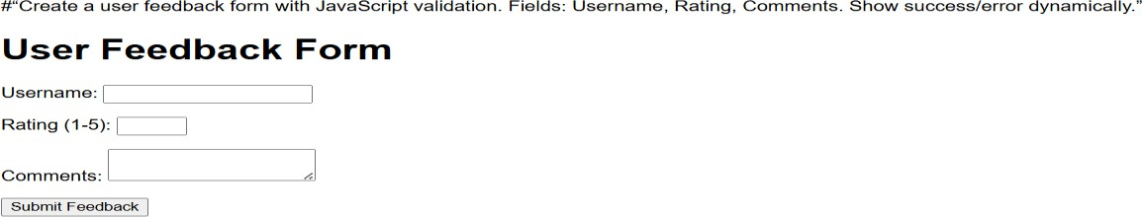

Task Description - 4 (Image Gallery with JavaScript)
• Task: Display a small image gallery on a web page.
Requirements:
• Use JavaScript to dynamically load images.
• Add next/previous navigation buttons.
• Use AI to optimize layout responsiveness.
Prompt: Develop an image gallery that switches images using next and previous buttons.
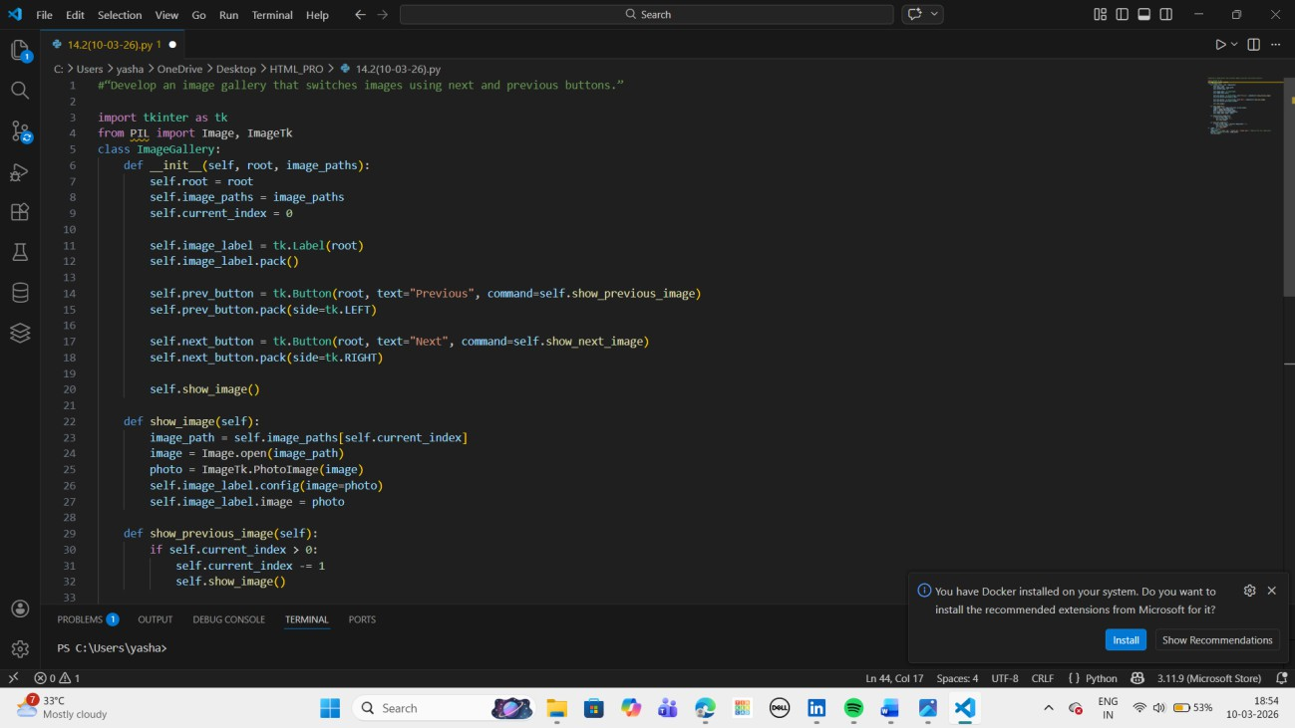
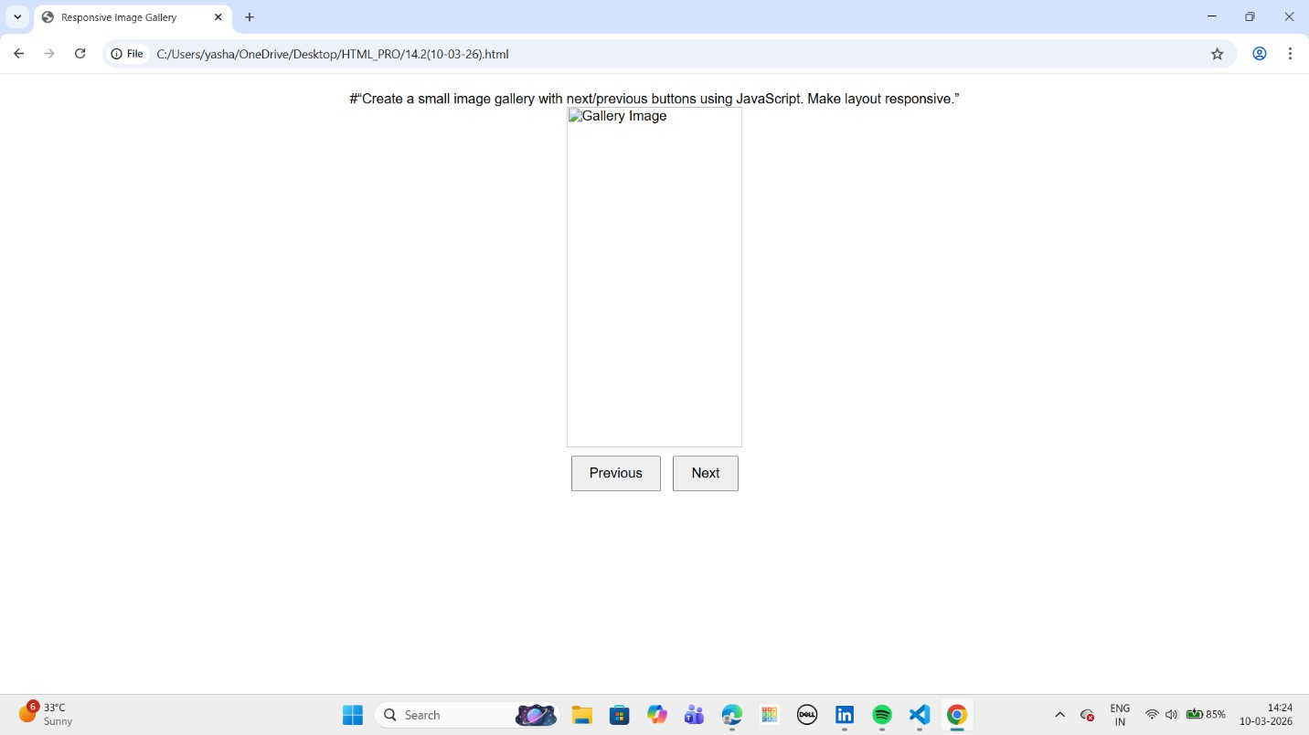

Description - 5: (Notification Banner)
• Display a notification banner at the top of the page.
Requirements:
• Use JavaScript to show and hide the banner.
• Style the banner using CSS.
• Use AI to ensure smooth transitions and clean UI behavior.
Prompt: Create a notification banner with show/hide functionality and smooth animation.
